Catholic
Alliance
For Charity and
Development

Meeting Minute
Of
Annual Retreat of Catholic Alliance on Charity & Development (CACD)

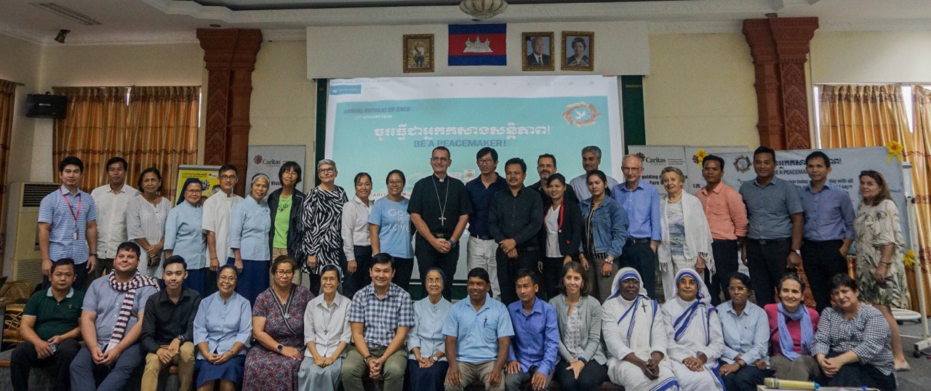

13th January 2020, Caritas Cambodia National Office

Chair: | - Bishop. Olivier Schmittaeusler, Vice Chairman of Caritas Cambodia
Moderator: | - Mr. Kim Rattana, Executive Director of Caritas Cambodia
Minute taker: | - Mr. Choun Moniroth & Mr. Duk Porheng
Participants: | - Attached Participant List
Agenda: | - Attached Agenda
Time: | - 1:30pm – 5:00pm
Time | Topic | Discussion & Decision
02:00 – 02:15 | Opening Remark and Prayer:  By Bishop Oliver Schmitthaeusler, Vice Chairman of Caritas Cambodia | The first annual retreat of CACD Meeting had been convened on 13th January 2020 at Caritas Cambodia National Office (#47, St. 198, Boeung Pralith, 7 Makara, Phnom Penh). There are 35 participants who are Chairman of Caritas, Catholic Representatives/Executive Directors, and Senior Leaders/Managers of CACD members to attend and share knowledge, experiences, the common challenges, best practices on the catholic alliance for development and prioritize the issues to be addressed by relevant stakeholders.  The meeting aims to create opportunity to all CACD members to share experience and knowledge with each other.  The first annual retreat of CACD meeting was presided by Bishop Oliver Schmitthaeusler, Vice Chairman of Caritas Cambodia. He began by thanking the CACD members who have contributed their value time joining this meeting as a whole for supporting CACD so far. At the same time, he also conveys this prayer to Sister Myna Porto who passed away.
02:15 – 02:30 | Self-introduction: Everyone | After a brief introduction on the topics to be discussed, all participants gave a round of self-introduction by telling their name, position and institution they coming from.
02:30 – 02:45 | Introduction:  By Mr. Kim Rattana, Executive Director of Caritas Cambodia | To start the meeting, Mr. Kim Rattana, Executive Director of Caritas Cambodia extended his welcome remark to all participants and he thanked all participants attending this annual retreat of CACD meeting. In this addition, he briefly explained the main objectives and topics to be discussed as follows:  - A moment of silent, Short presentation in memory of Sr. Myrna DC for her devoted action at Takeo Eye Hospital  - Special reflection on “Be a peace Maker”  - Follow-up action plans  - To announce on upcoming events and compliance issues
02:45 – 03:00 | Agenda 1: A moment of silent, Short presentation in memory of Sr. Myrna DC for her devoted action at Takeo Eye Hospital, by Mr. Te Serey Bonn, Program Director of Takeo Eye Hospital | This session was facilitated by Mr. Te Serey Bonn, Program Director of Caritas Takeo Eye Hospital and DC team. They expressed their special thanks to all CACD members. At the same time, Mr. Serey Bonn has shown one short video clip in the memory of Sr. Myna DC for her devoted action most of her life for Caritas Takeo Eye Hospital.  “Bangsrey helped a lot of people in Thailand with illness. She helped them without discrimination. In 2000, she came to help Caritas Takeo Eye Hospital after Maryknoll. She helped people living with HIV/AIDS but she volunteered to do it. After that she started to work at Takeo Eye Hospital”, he added.  In the video clip, it was shown about the contributions, dedication, commitment, to build new building, building new vision centre in Kirivong District, CBM Australia meeting for building hospital, Visit activities of Caritas Cambodia executive director, new hope for blind people after treatment, internship student in the hospital.  See the video for more information!
03:00 – 04:00 | Agenda 2: Brief Report on CACD 2019 and the follow-up points, by Mr. Choun Moniroth, Senior HR Officer of Caritas Cambodia | This session was facilitated by Mr. Choun Moniroth, Senior Human Resource Officer, Caritas Cambodia. He reviewed the summary discussion points and key action plans of a one-year CACD meeting in 2019 to all participants as below:  Discussion points:  - Reflection on who we are as members of Catholic Alliance on Charity & Development (CACD) in Cambodia, By Bishop Oliver Schmitthaeusler, Vice chairman of Caritas Cambodia.  - Reflection on Catholic Social Teaching, By Mr. Marc D’Silva, Regional Director, Catholic Relief Service.  - Discussion on common challenges on the three sectors (family issues, education issues and youth issues) and action to put together as members of CACD, By Mr. Kim Rattana, Executive Director, Caritas Cambodia.  - Discussion on Land Ownership and Taxation of NGO/Associations in Cambodia by: Mr. H.E. Chiev Song Hak, Representative from International Lawyer Firm.  - Reflection on Laudatosi and Concreate action plan, By: Fr. Gabriel SJ.  - Brainstorm the idea to discuss the joint or consolidated action to systematically address climate change matters and repercussions, By Mr. Manfred Staab, Country Representative of Caritas Czech Republic  - Sharing of Best Practices and Action Plans of Climate Change:  - Presentation on Green Growth Strategy & Climate Change Best Practice, by Khim Sandab, MoE  - Presentation on Solid Waste Management Action Plan, By Mr. Nget Vibol, MoE  - Presentation on Experience of CSO Implementation related to CCA and NRM, By Mr. Tek Vannara from NGOF  - Presentation on Youth Involvement in Climate Change and Environment, By Seth Likheang, Young Eco Ambassador  - Brainstorming on possible climate resilience action by CACD members  Action Points:  Family Issues  - Visit the family follow dialogue methodology, work together and talk with them and reflect together  - Educate them about the living values, domestic violent and talk with them face to face  - Build temporary shelter to welcome young girls.  Education Issues  - Catholic church, NGOs, and other CSC institutions work together in the future to promote education;  - Adapt education for those who dropped out school;  - Follow-up teaching methodologies and proper action plan at school;  - Upgrade training publication.  Youth Issues  - Provide more skills to young people;  - Provide workshop for the families to exchange their mind on relevant issues  - Enhance collaboration and relationship with parents, local authorities to get more involvement;  - Implement more activities at the remote areas.  - Technical Working Group of Climate Change has been formed. The Technical Working Group of Climate Change consists of CRS, CAFOD, CSC, KBO, SJ, Maryknoll, Caritas Czech Republic and Caritas Cambodia.  - Term of Reference of Technical Working Group will be developed.  - All members required to share possible action to respond to climate change to develop climate resilience working group.  See the document for more information!
04:10 – 04:50 | Agenda 3: Special reflection “Be a peace Maker”, By Bishop Oliver Schmitthaeusler, Vice Chairman of Caritas Cambodia | The session was facilitated by Bishop Oliver, the Vice Chairman of Caritas Cambodia. He emphasized that there are three main areas to be discussed and shared today as follow:  - A call for everyone to be a peace maker in our society  - A sharing of experience by local NGO  - Peace maker from the perfective of Higher Education  I will today say something about Peace Day from the Samdach Pope’s letter in 2020. Every January of the year, we have World Peace Day and it is a letter from Samdach Pope Paul IX in 1967. This year we have this topic “Peace is a Journey of Hope” with three main topics (i) we have to dialogue, (ii) we have to coordinate and (iii) we have to consider ecological convention.  After his introduction to the session, he briefed about the topic and presented short video about atomic bomb in Hiroshima, Japan. In the video, Bishop mentioned that the United States detonated two nuclear weapons over the Japanese cities of Hiroshima and Nagasaki on August 6 and 9, 1945 and the witness of peace in Japan; Dr. Takashi Nagai who was a Catholic physician specializing in radiology, a survivor of the atomic bombing of Nagasaki and an author of many books for peace building in Japan.  See the video for more information!  After the video show, Bishop Olivier, concluded that there are many buildings destroyed and many people died. At the same time, Bishop mentioned that in the Samdach Pope letter says that Peace is the journey of hope. He also mentioned that if we lost hope it means that we are losing life as well. He said that we used to face world war I and II using weapons to destroy the world.  At the same time, Bishop mentioned that there are three main questions in Samdach Pope’s letter that we have to reflect. how do we undertake a journey of peace and mutual respect? How do we break the unhealthy mentality of threats and fear? How do we break the current dynamic of distrust? Bishop also mentioned that there are three way to build peace through the following factors:  - Education  - Peace Village  - Social Enterprises and Agriculture  See the documents for more information!  At the end, Bishop suggested all CACD members to watch one short video clip of activities of Phnom Penh Catholic Church to build peace together for the next three years about peace, love, and compassion.  After sharing from the Bishop, Mr. ForumZFD (Forum Civil Peace Service), briefed about ForumZFD/Forum Civil Peace Service.  ForumZFD is a German non-governmental organization (INGO) for non-violent conflict transformation, established in 1996. ForumZFD implements programs of the Civil Peace Service in Europe, Middle East. ForumZFD established in 2015. ForumZFD is implementing three main projects such as peace education, dealing with the past, and peace building. In Peace Education, he mentioned that ForumZFD Cambodia provide trainings and workshops on conflict transformation and train the trainer program with SBUBB.  In addition to this, he mentioned that the vision of ForumZFD is to:  - Rule of Khmer Rouge and following civil war left a deep mark on Cambodia and its people till today  - Past decades of conflict and war let to decreased trust among Cambodian people and created division between communities  - No systematic dealing with the recent history in Cambodia  - Little chance for survivors to deal with their memories  - To have a sustainable peaceful future we believe that it is important for Cambodians to know about their own past and to be enabled to learn about it  - Building trust and good relationships between diverse groups and communities to foster understanding and respect for different experiences, traditions and cultures  See the documents for more information!  After sharing from ForumZFD, the facilitator requested all participants to question. Some questions were asked and answered as follows:  - Q1: How do you deal with the past before, during, and after the Khmer Rouge. A1: We have to meet with the people. What do you expect and what other expect? We provide training on conflict transformation, the way to communicate with each other, type of dialogue. Also, we provide training on peace building and dealing with the past. In this particular, we have been working with relevant people and let them to understand what are the impact from the past. This is our methodologies to work with them.  After question and answer, the facilitator invited PhD. Sreang Sary, from the Research Institute to share about the peace building experiences.  I was born in Camp Site 2 in 1971. I had been through the war. I grew up in the site camp under support from the UNICEF. Today, I want to share about the agent. We have two different types of student from diversity of people. Please remember that as a teacher you have the responsibilities to develop the cognitive, emotional, physical, and social characteristics of your student and make sure you have the ability to shape their lives.  He mentioned about the knowledge and Understanding that all students need to equip. There are three main factors such as:  - Knowledge and Understanding  - Skills and Abilities  - Value and Attitude  - Q2: Do you create this idea to educate other school, teacher or you apply it for yourself? A2: In the institution, in the foundation year, we can only initiate 3 main ideas such as: diversity. Also, we can share with the teacher and student through workshop. But it is not very high impact. We should create a training curriculum or learning mechanism.  In this addition, Mr. Kim Rattana, Executive Director was impressed by the letter from the Catholic Justice in peace building such as:  - Acknowledge the dignity of every human being  - Engage with others non-violently  - Forgive  - Reject violence  - Support and celebrate cultural diversity  - Provide a meeting place  - Give help and seek support  - Cultivate an attitude of gratitude  - Attend to prayer and your spiritual development  - Reflect on your day as a peacemaker  The facilitator requested all participants to reflect on CACD being a peacemaker? As a CACD member, how do you build peace in our work, family, society? The participants answered as follows:  - As an organization leader, we should include some sessions in training curriculum such as Philosophy, History, and Social to our next generation. What are the challenges that we face if we want to build peace? We have to identify issues and find solutions. For education sector, we have to identify education issues. Also, why the ministry removes some necessary subjects from the education program. If you can mobilize idea or perspectives from other Universities, it is good. If we are alone, we cannot make any change.  - Mr. Sreng mentioned that it is complicated to include those subjects in the education program since the Ministry of Education, Youth and Sports decided to remove those subjects since there are not many students interesting on those subjects. The students are interest in the field of Management, Marketing, Accounting and so on. That’s the reason why the Ministry did it.  At the end of the session, the facilitator invited all CACD members sign on a commitment banner of Be a Peacemaker on the theme “I promise to be a peacemaker today and every day with all may actions, in all my thoughts and in everything I say”.  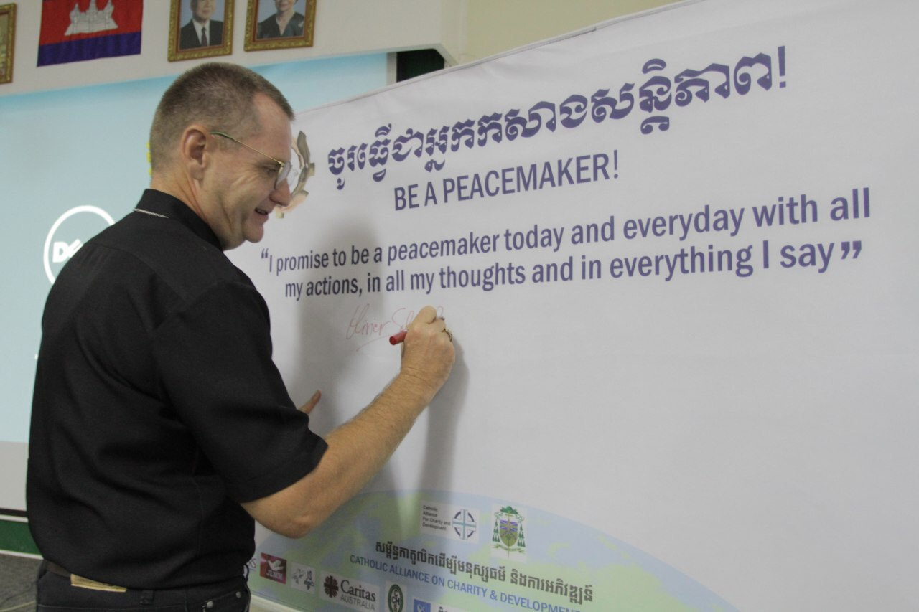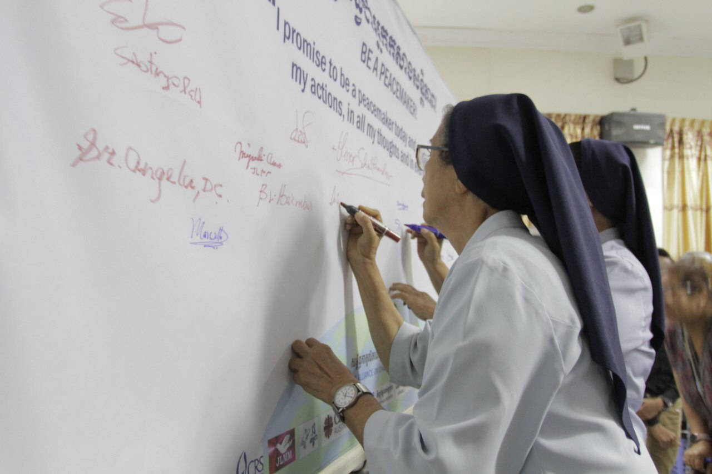
04:50 – 05:00 | Concluding Remark  By: Bishop Oliver Schmitthaeusler, Vice Chairman of Caritas Cambodia | The first annual retreat of CACD meeting was conducted successfully with actively participated by all participants and professionally supported by our honor quest speakers and fruitfully produced great outputs as expected related to best experiences and practical actions toward peace building concept.  All in all, this learning forum provided a great opportunity for CACD members to build stronger network and share experiences, challenges and put together actions to build peace in Cambodia. We, Caritas Cambodia, as an organizer, are very proud of this fruitful result.  At the end of meeting, Bishop Oliver concluded the meeting by thanking all participants for their great involvement and sharing.
Next CACD Meeting |  | - 23rd March 2020
-End-

